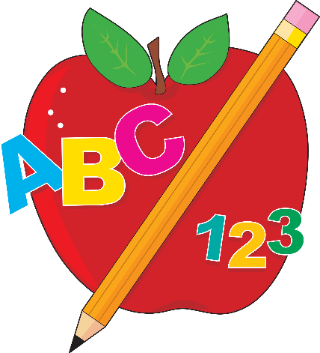
Mrs. Strahorn’s 1st Grade
Daily Schedule
7:15-7:50 | Unpack  Breakfast  Head Sprouts/Read
7:50-8:00 | Morning Announcements
8:00-8:10 | Calendar/Number Talks
8:10-9:10 | Readers Workshop
9:10-10:10 | ELA/Writers Workshop
10:10-10:35 | Intervention/Phonics
10:35-10:57 | Science/Social Studies
10:57-11:27 | Lunch
11:27-11:45 | Recess
11:45-11:55 | Restroom/Water
11:55-12:10 | Word Problem
12:15-1:05 | Specials
1:10-2:00 | Math Mini Lesson/Math Groups
2:00-2:20 | Folders/Clean Up/Pack Up  Snack/Dismissal

