Homework Choice Board – February and March
Please choose 1 activity each night and complete it in the Homework Journal. Please choose 4 activities each week. Parents please write the date completed in each box as your child completes the activity. Please have your child write on both sides of the paper in the homework journal to maximize space for the entire school year. Please do not allow your child to draw/doodle in the journal. Homework should be turned in NEAT, in the student’s BEST HANDWRITING, PENCIL ONLY, ON TIME, CLEAN, DRY, and free of FOOD and DRINKS. Return the journal to school EVERY Friday to be checked.
Draw a venn diagram. Compare and contrast yourself to your teacher.  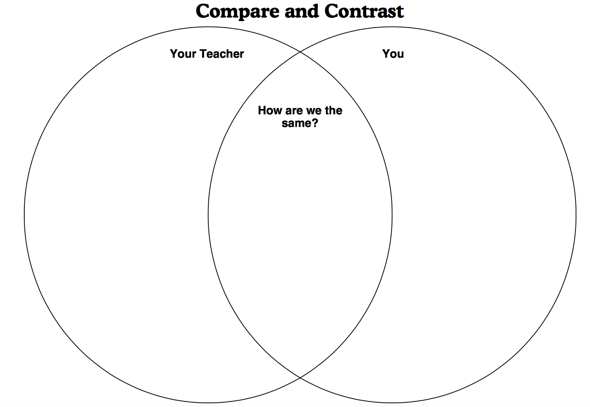 |  | Write the 4 basic needs of an animal? | Write 4 sentences using the these conjunctions:  and  or  but  so | Which pet had the most?  Which pet had the least?  How many more children like cats than hamsters?  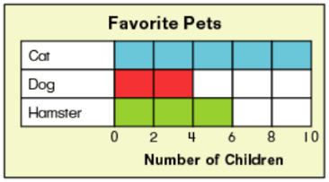  How many children like pets all together?
Draw a venn diagram. Compare  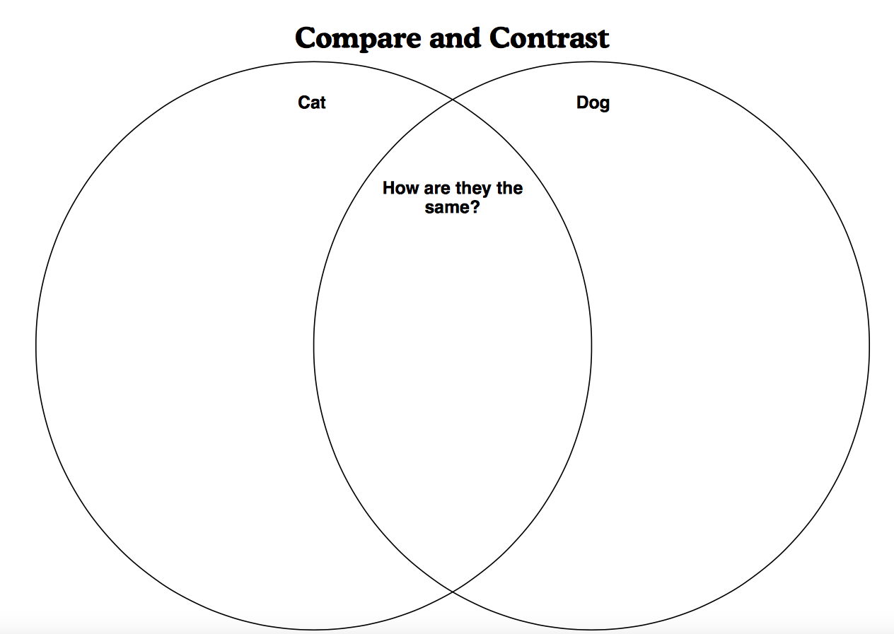  and contrast cats and dogs. |  | Write the equation and add and subtract:  29 – 10 = ___  34 – 10 = ___  65 – 10 = ____  49 + 10 =___  54 + 10 =___  75 +10 =___ | Cone-  How many faces? ____  How many edges? ___  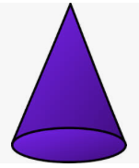  How many vertices? __ | Write the equation and find the missing addends:  8 + __ = 12  9 + __ = 17  __+ 5 = 10  __ + 9 = 20  13 + __ = 16 | Cube-  How many faces? _____  How many edges? _____  How many vertices? ___  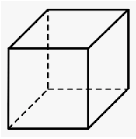
Write each sight word in a sentence and circle the sight word.  page  need  think  thing  world  show  turn | Write each number and make tally marks for each. Remember to cross on increments of 5.  5 = _____  8 = _____  16 = _____  20 = _____  22 = _____ | Spelling Patterns:  Think of 6 words with the sounds “ai” and “ay.”  Write a sentence for each word and circle the words. | Spelling Patterns:  Think of 6 words with the sounds “oi” and “oy”  Write a sentence for each word and circle the words. | Write each sight word in a sentence and circle the sight word.  know  around  animal  answer  change  very  try | Spelling Patterns:  Think of 6 words with the sounds “ee” and “ea.”  Write a sentence for each word and circle the words.
How many sides and angles on each shape?  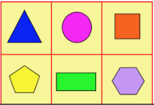  Rectangle-  Circle- Pentagon-  Square- Hexagon-  Triangle- |  |  | Write 10 more and 10 less to each number.  _____ 54 _____  _____ 87 _____  _____ 32 _____  _____ 12 _____  _____ 90 _____ | Write >, <, or =.  50__40  35__70  0__0  42__24 | What is your favorite snack?  List 3 reasons why.  I think _____ is my favorite snack Let me tell you why. One reason is because…….
The teacher will initial each date below as the students complete and turn their homework journals in each Friday.

Feb 7_____ Feb 14 _____ Feb 28____ Mar 6_____ Mar 13_____ Mar 20 _____ Mar 27_____

