Making Connections Monday
How are they similar and how are they different?
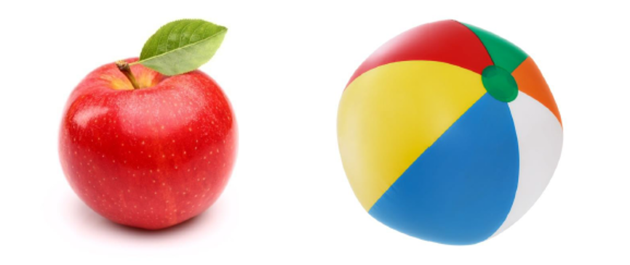
Picture 1 Picture 2

