Making Connections Thursday
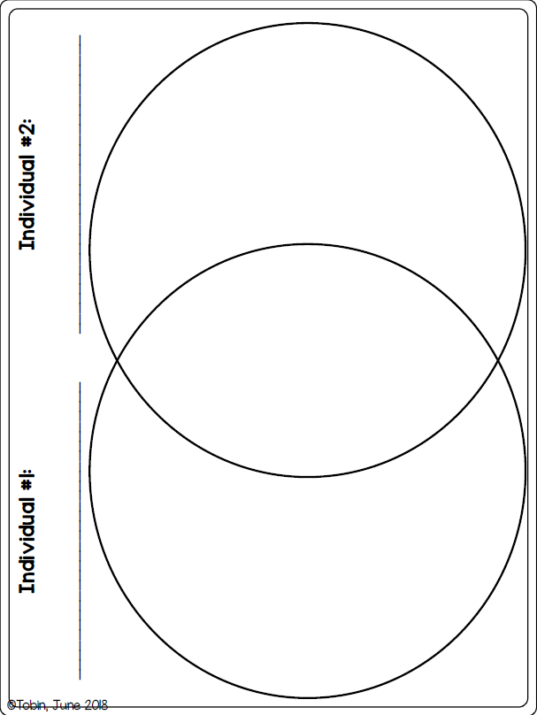
How are you and a family member similar and different?

