Phonics Practice: au, aw, al, ou
Monday: write all words 3 times each | 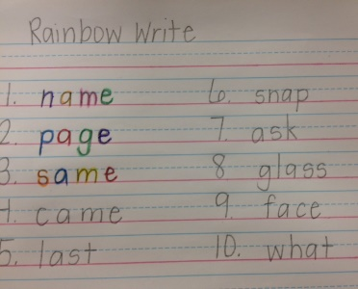  Tuesday: rainbow write all words (use a different color for each letter)
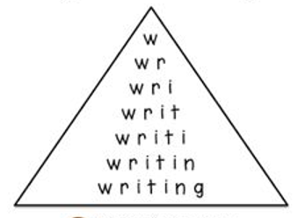  Wednesday: pyramid write all words | 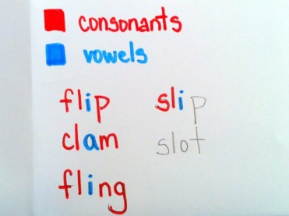  Thursday:  write each word, then circle the vowels blue and the consonants red

